**8-BIT DIVISION**  
  
  
**EXP NO: 4**  
  
**AIM:**

To write an assembly language program to  
implement 8-bit division using 8085 processor.  
  
**ALGORITHM:**

1)      Start  
the program by loading a register pair with the address of memory location.  
2)      Move  
the data to a register.  
3)      Get  
the second data and load it into the accumulator.  
4)      Subtract  
the two register contents.  
5)      Increment  
the value of the carry.  
6)      Check  
whether the repeated subtraction is over.  
7)      Store  
the value of quotient and the reminder in the memory location.  
8)      Halt.  
  
  
   
  
  
**PROGRAM:**  
  
 LDA 8501

MOV B, A  
LDA 8500  
MVI C,00  
LOOP:   CMP B  
JC LOOP1  
SUB B  
INR C  
JMP LOOP    
LOOP1:  STA 8502  
MOV A, C  
STA 8503  
RST 1

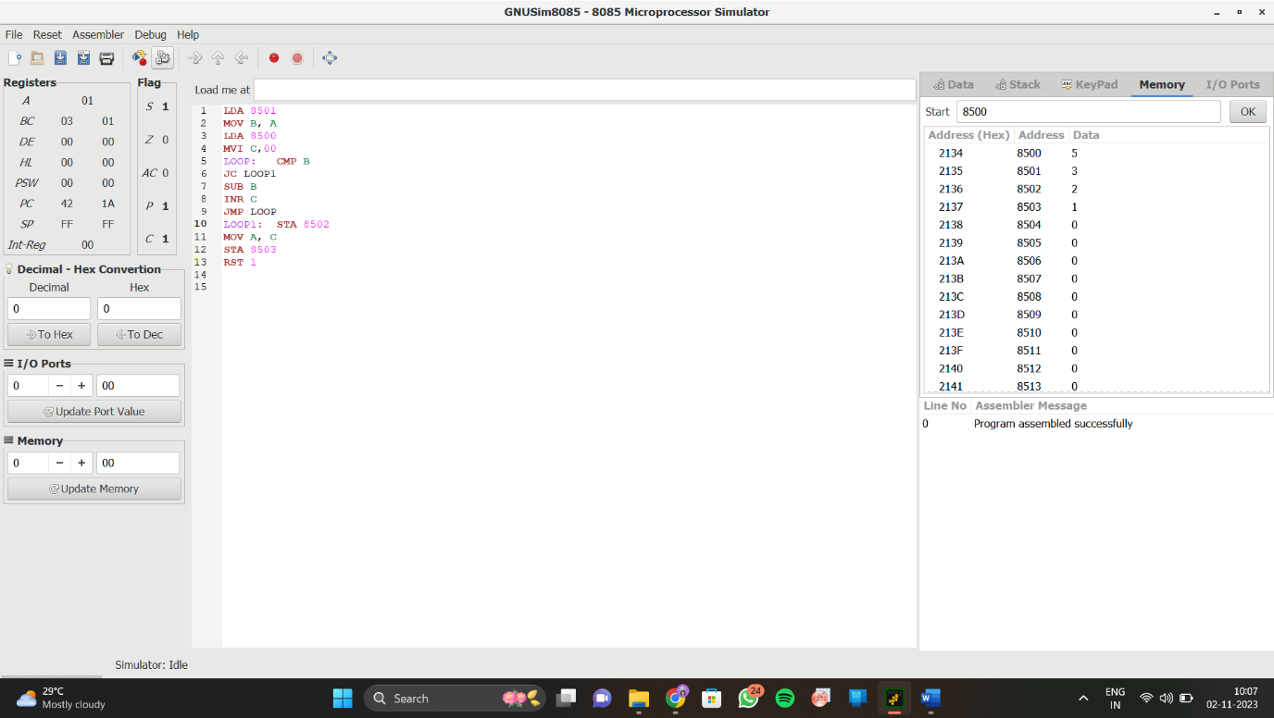**INPUT:**  
  
  
  
  
  
  
  
  
**OUTPUT:**

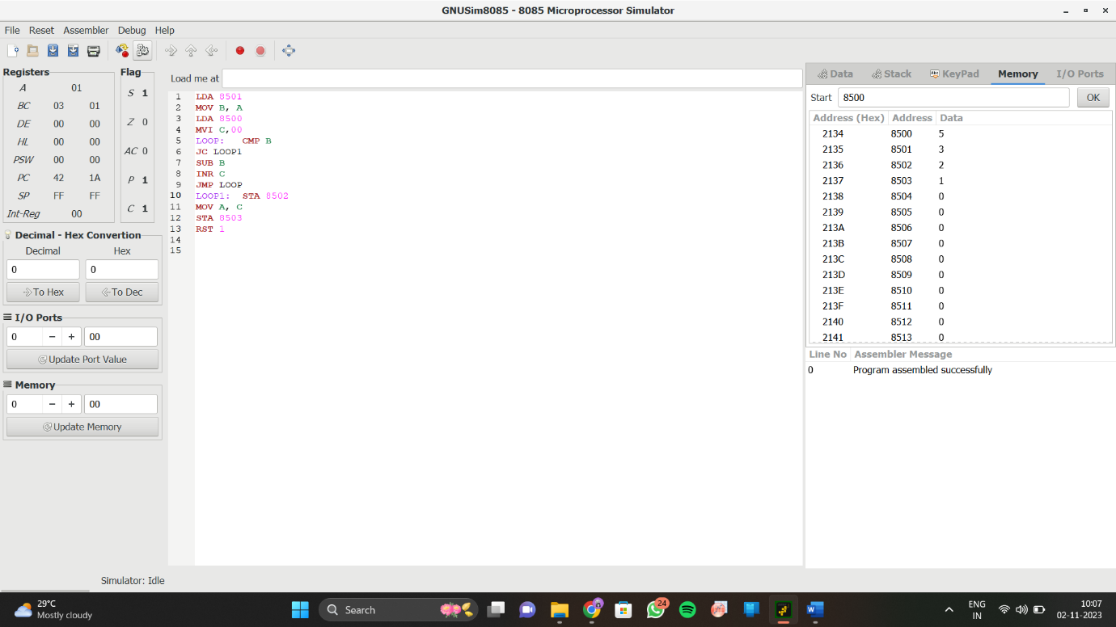  
  
  
 

**RESULT:**

Thus the program was executed successfully using 8085  
processor simulator.